Adolfo T. Javier León 2614 Computer Forensics Forensic Analysis Report – Phase 3
- Evidence Summary
  - List of evidence analyzed
    - Disk Image
      - Kali_disk.raw.raw
    - PCAPNG
      - network_capture_youtube_ping.pcapng
  - Hash values
    - MD5
      - 82a022bfed3fff6800693947f058378f
    - SHA256
      - f60bba51c5e743c41eac77c8af068df3257de53fd5ac71686bf1cb98739ab992
    - 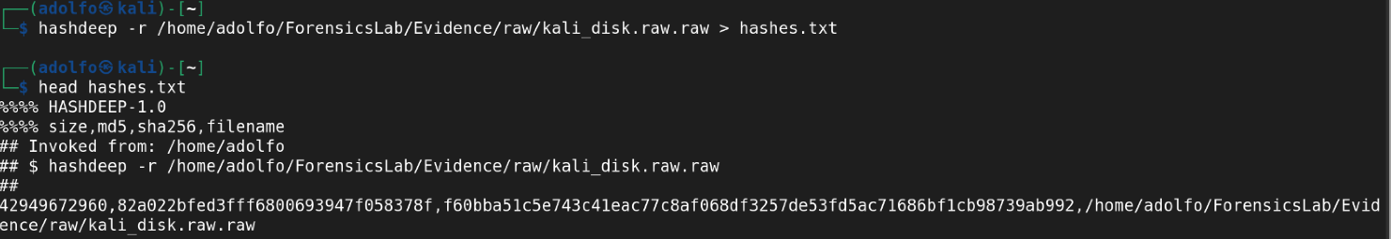
  - Acquisition date/time
    - The disk image and network capture were acquired on 05/04/26.
  - Chain of custody confirmation
    - Evidence is stored in
      - “/home/adolfo/ForensicsLab/Evidence/raw”
      - “/home/adolfo/ForensicsLab/Evidence/network”
    - Hashes confirmed and documented.
    - All analysis performed on read-only copies.
- Tools and Methodology
For each evidence type:
  - Disk Image Analysis
    - Tools used
      - Sleuth Kit (TSK)
      - Strings
      - Hashdeep
    - Commands executed
      - Partition
        - mmls /home/adolfo/ForensicsLab/Evidence/raw/kali_disk.raw.raw
      - Metadata
        - fsstat -o 2048 /home/adolfo/ForensicsLab/Evidence/raw/kali_disk.raw.raw
      - Deleted Files
        - fls -o 2048 -r /home/adolfo/ForensicsLab/Evidence/raw/kali_disk.raw.raw
      - Recovered deleted files
        - icat -o 2048 /home/adolfo/ForensicsLab/Evidence/raw/kali_disk.raw.raw 864942 > recovered_864942
        - icat -o 2048 /home/adolfo/ForensicsLab/Evidence/raw/kali_disk.raw.raw 865083 > recovered_865083
        - icat -o 2048 /home/adolfo/ForensicsLab/Evidence/raw/kali_disk.raw.raw 1469402 > recovered_1469402
      - Strings
        - strings /home/adolfo/.mozilla/firefox/2twx34lr.default-esr/places.sqlite | head
        - strings recovered_1469402
      - Hashes
        - hashdeep -r /home/adolfo/ForensicsLab/Evidence/raw/kali_disk.raw.raw > hashes.txt
        - head hashes.txt
    - Rationale for tool selection
      - Sleuth Kit was selected for low-level forensic access to EXT4 files, enabling partition analysis, metadata extraction, and deleted files. Strings used to extract readable artifacts from binary files and browser databases. Hashdeep was used to verify the integrity of evidence using MD5 and SHA-256 hashing. All selected tools are from the Phase but are also industry standards.
    - Any deviations from standard procedure
      - No deviations from standard procedure; all analyses were performed on a forensic copy of the disk using read-only tools.
  - Network Capture Analysis
    - Tools used
      - Wireshark
      - Files
      - Terminal
    - Commands executed
      - ping -c 4 youtube.com
    - Rationale for tool selection
      - Wireshark is the industry standard for packet-level forensic analysis that allows detailed inspection of DNS, ICMP, and other protocols. The ping command generates traffic for the analysis, making it predictable and controlled. Using the filter on Wireshark allows isolating the relevant packets to identify suspicious IPs, domains, or anomalies. On Files, it was used to verify the PCAPNG metadata, supporting the chain-of-custody documentation.
    - Any deviations from standard procedure
      - No deviations occurred
      - The PCAP file analyzed was the same evidence collected during Phase 2, stored in the proper evidence directory:
        - /home/adolfo/ForensicsLab/Evidence/network
      - Analysis was performed on a forensic copy of the PCAPNG file.
      - No modifications were made to the original evidence.
- Findings and Interpretation
  - Suspicious files or processes
    - No suspicious files or processes were identified on the disk image.
      - Recovered DLL files only contained standard Microsoft Edge codes.
        - 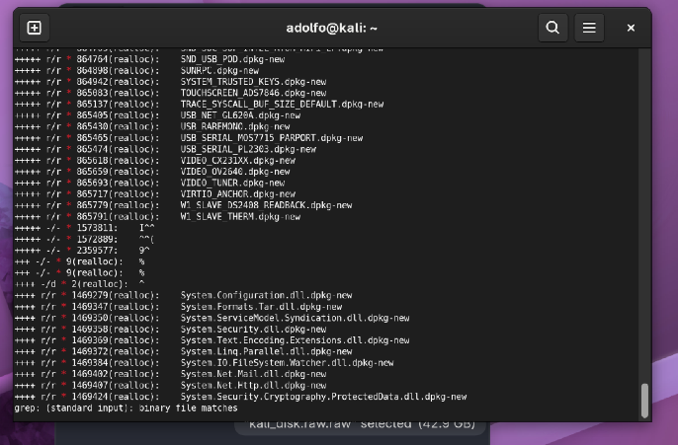 Deleted files identified by fls
      - During the disk image analysis, the three deleted files were chosen to successfully recover using icat from the EXT4 file system. These recovered artifacts are required for forensic documentation.
        - 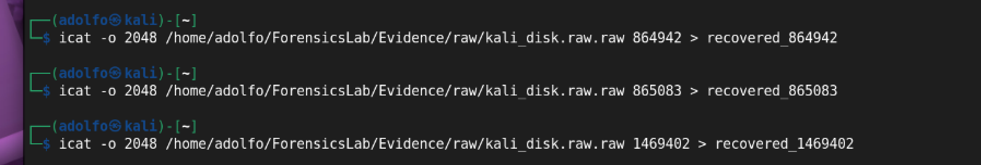Recovered DLL files using icat
        - 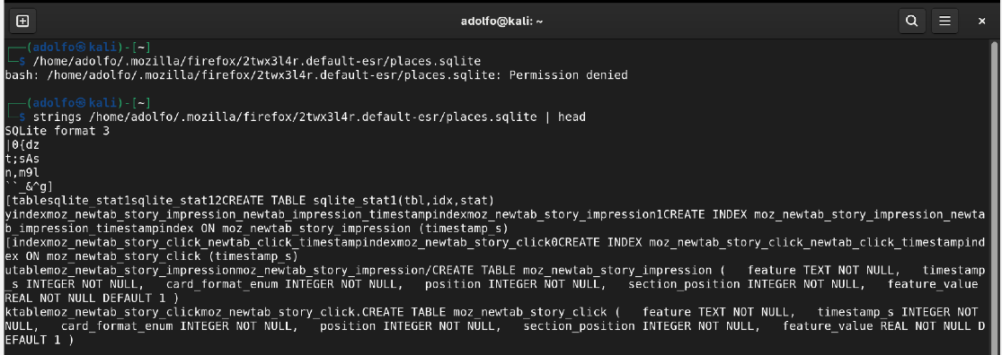Browser database structure
  - Indicators of compromise (IOCs)
    - No IOC was detected across the disk image and network capture.
      - 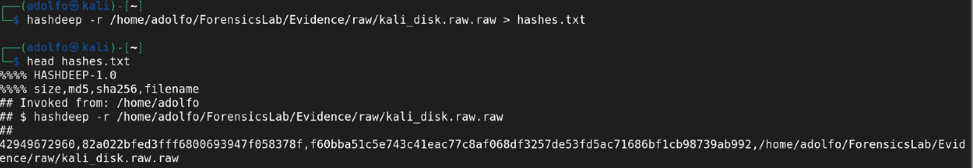
  - Malware behavior (if applicable)
    - No malware found
      - 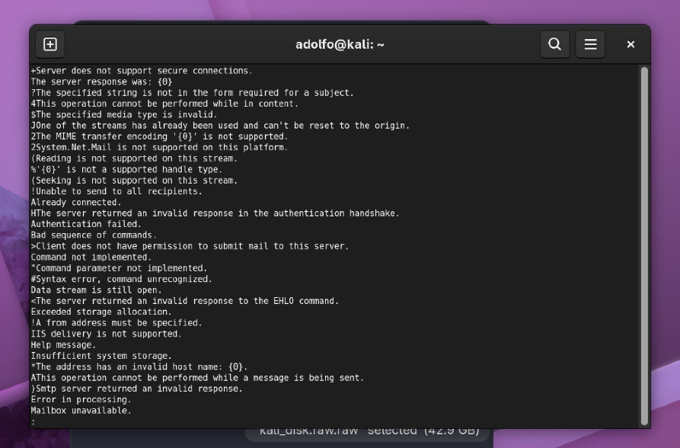
  - User activity timeline
    - Disk activity shows normal user activity, but by the time it started to capture, it only showed browser history entries for YouTube.
      - 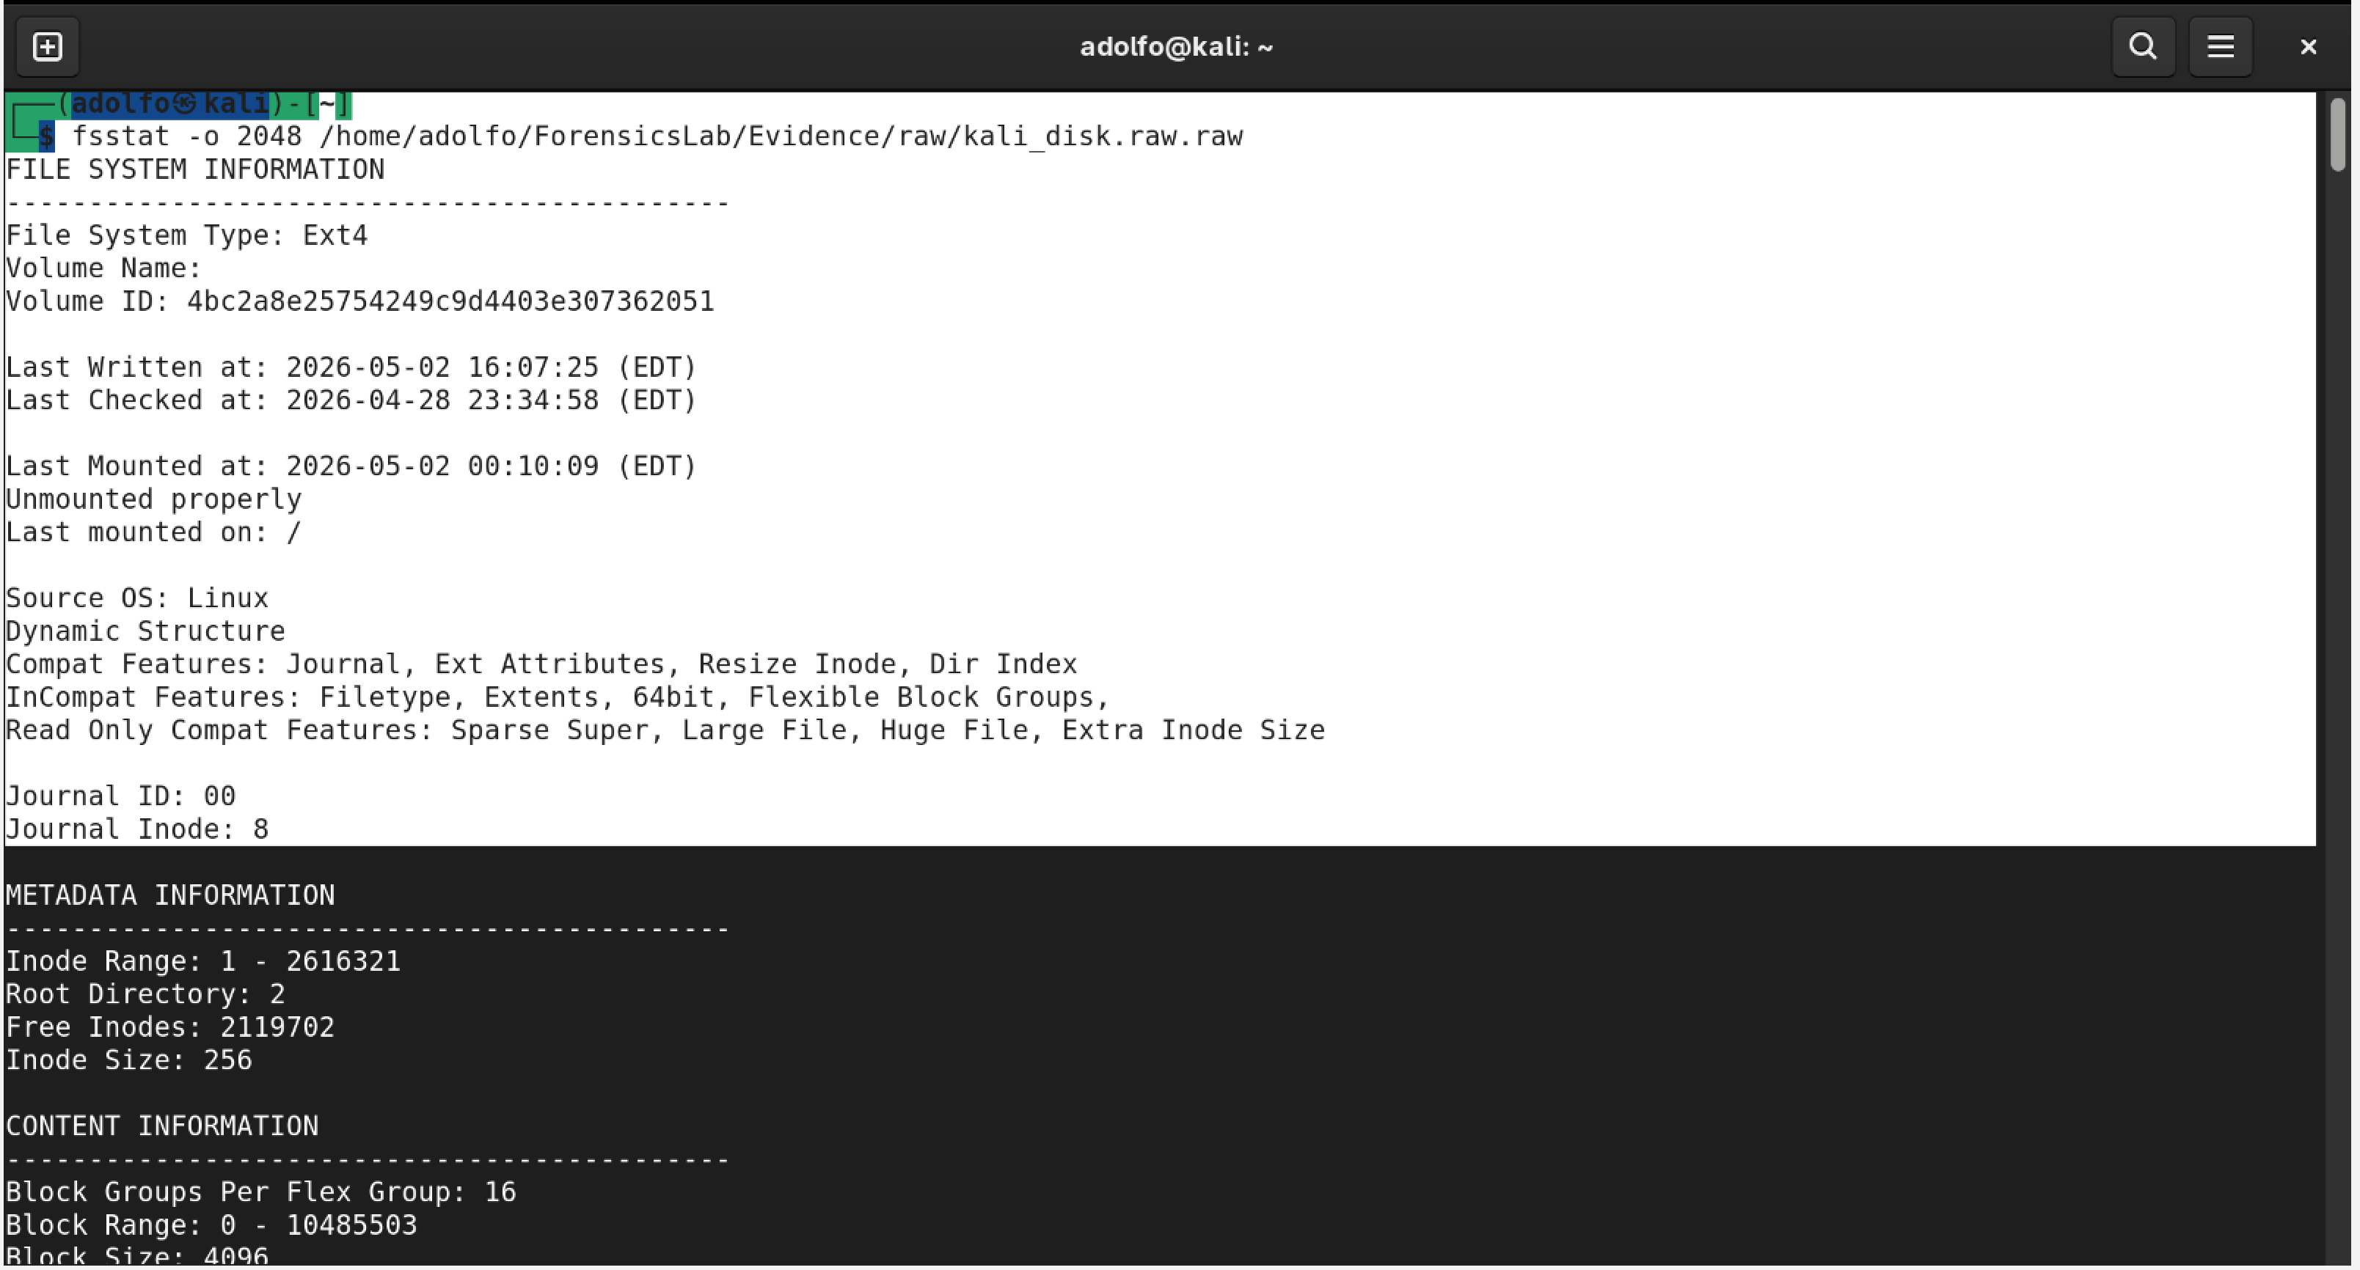
    - Network traffic shows intentional ICMP + DNS activity generated by the ping test.
  - Network anomalies
    - Network capture contained
        - 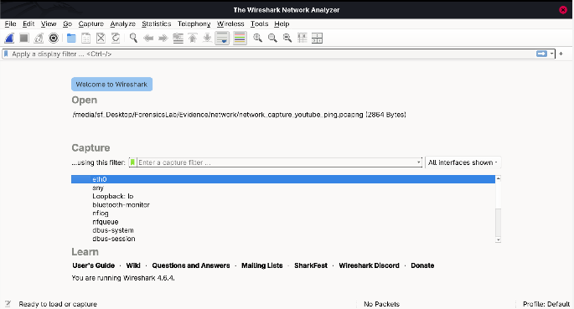
        - 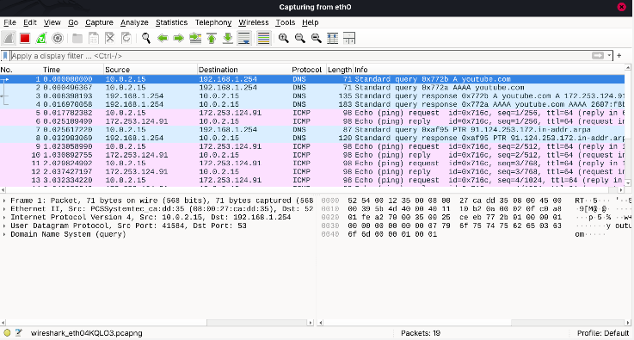
      - DNS queries for youtube.com
        - 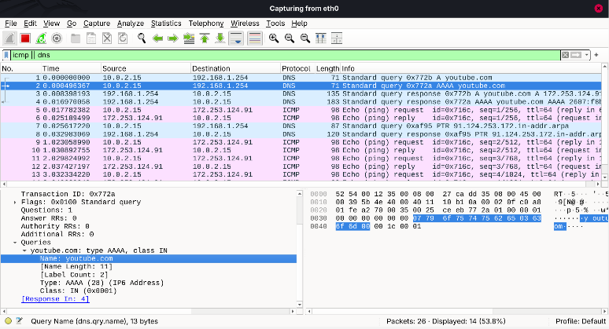
      - ICMP echo requests/replies
        - 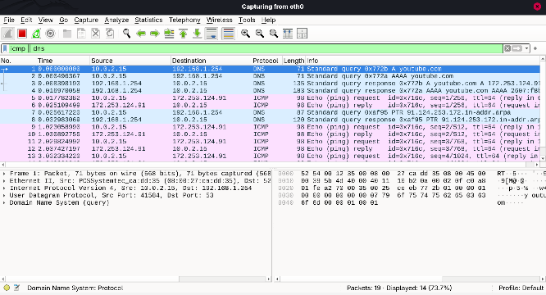
      - Normal IPv6 multicast traffic
  - Correlation across evidence sources
    - Disk timestamps occurred before the network capture.
      - 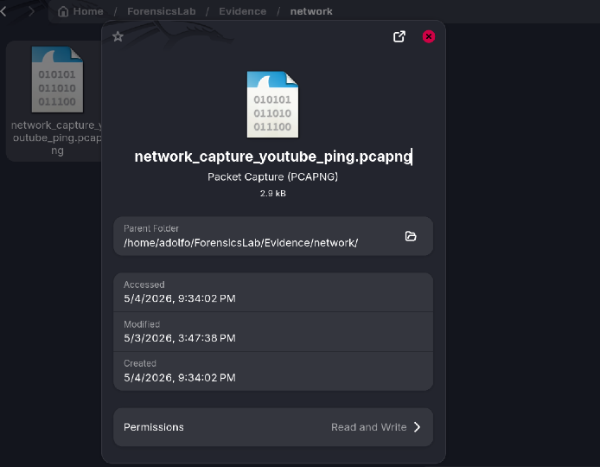
    - Network timestamps show only ICMP + DNS traffic
- Timeline Reconstruction
  - File system timestamps.
    - The file system timestamp extracted from the disk image analysis was from using fsstat and fls, which showed normal system activity. The deleted DLL files had timestamps consistent with routine system cleanup, and browser history timestamps aligned with daily user browsing behavior.
  - Network packet timestamps.
    - Network packets timestamps were obtained from Wireshark, showing ICMP echo and DNS queries traffic generated during the intentional “ping -c 4 youtube.com” test. All packets occurred on 05/04/26, and no network activity overlapped with suspicious disk events. No additional anomalies occurred, nor were any unexpected timestamps observed, in the PCAPNG.
  - Log entries
    - No log entries were made since there were no indications of unauthorized access or abnormal authentication attempts. Disk image and network capture timestamps showed no correlation with compromised or malicious activity. All observed behavior was consistent with normal system operation.
- Conclusion and Assessment
  - The system only showed normal user activity with no sign of compromise, malware, suspicious network traffic, or unauthorized access based on both disk image and network capture. All deleted files were recovered, timestamps and data were consistent with routine system behavior, and nothing indicated that the system had been compromised. In a real investigation, additional steps such as memory analysis, deeper log review, and threat- intelligence checks would be performed to fully validate the system’s integrity.

